**PROJECT WORK**

* **Project Title**

Design and implementation of an induction motor drive system using Arduino Uno and single-phase H-Bridge inverter.

* **Objectives**
* To get a better understanding of single-phase H-bridge inverter
* To understand the designing process of single-phase H-bridge inverter
* To get familiar with the practical implication of single-phase H-bridge inverter along with Arduino UNO
  + **Apparatus**

|  |  |
| --- | --- |
| Driver A3120 Optocoupler (2 pcs) | LED (2 pcs) |
| MOSFET IRF 240N (2 pcs) | Diode (2 pcs) |
| Two pin connector (2 pcs) | Capacitor (100μF; 2 pcs) |
| Three pin connector (2 pcs) | Resistor (1kΩ 4 pcs; 470Ω 2pcs) |
| 8 pin IC holder (2 pcs) | Flexible wire |

* + **Experimental connection**

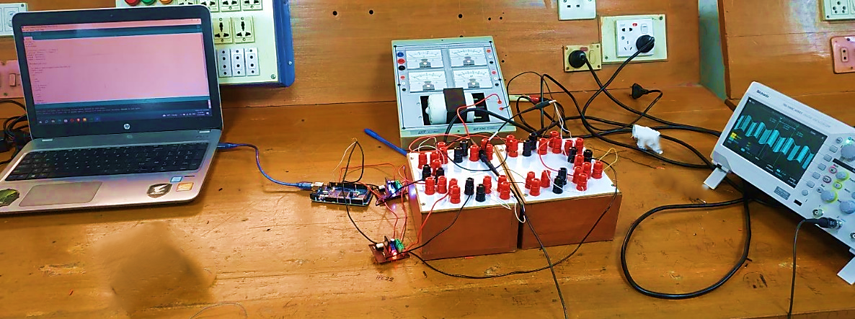

**Fig. 1:** Experimental connection

* + **Arduino Code**

**int angle =0;**

**int dr=10;**

**void setup()**

**{**

**pinMode(11, OUTPUT); // Timer 2**

**pinMode(3, OUTPUT); // Timer 2**

**TCCR2A = B10110001;**

**TCCR2B = B00000101;**

**TIMSK2 = B00000001;**

**}**

**ISR(TIMER2_OVF_vect)**

**{**

**int duty = (255*sin(angle*3.1416/180)+255)/2;**

**OCR2A = duty;**

**if (duty==0){**

**dr=0;**

**}else{**

**dr=10;**

**}**

**int y= duty+dr;**

**if (y>=255){**

**y=255;**

**}**

**else{**

**y=y;**

**}**

**OCR2B=y;**

**angle = angle +5;**

**if (angle >360)**

**{**

**angle =0;**

**}**

**}**

**void loop()**

**{**

**}**

* + **Waveform**

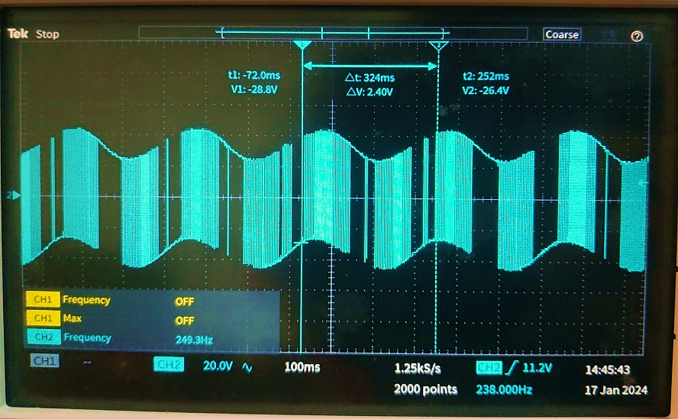

**Fig. 2:** The output waveform of induction motor

* + **Discussion & Conclusion**

In this experiment, we successfully carried out the design and implementation of single-phase H-bridge inverter using an Arduino Uno. Our approach involved meticulous programming of the Arduino Uno to align with the project requirements. The induction motor, originally rated at 110V AC, exhibited an RMS voltage significantly below its rated voltage. To initiate motor activation, we adjusted the frequency accordingly. Thus, the induction motor operates at a lower frequency than its rating when the voltage falls below the rated frequency. Thus, the desired project output was obtained.